AGGIE SQUARE / MIXER FIELD GUIDE
Tuesday, November 10, 2026 • Connect Labs Sacramento • RSVP lead research, not confirmed attendance
Objective: Find a paid biomedical-device or neurotech internship where you can build verification experience: test automation, requirements traceability, acquisition reliability, embedded testing or hardware-in-the-loop.
How to use: Meet Ajith and Monique first; then one working engineer and one company/network connector. Photographs are from public organizational pages, not scraped from private LinkedIn. Initials mark unavailable verified portraits; links below each name open the source/profile.
PHOTO | NAME | TITLE / COMPANY | BACKGROUND | WHAT THEY DO | WHAT TO TALK ABOUT
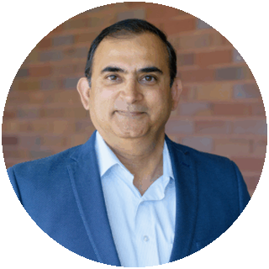  PHOTO SOURCE | Ajith Anand  01 • FIRST  PROFILE / BIO | Lab Director  Connect Labs / Wexford | PhD/MBA biotech R&D leader; previously MyFloraDNA, Corteva and Conception Nurseries. Has built laboratories and startup programs. | Operates Connect Labs Sacramento, recruits life-science tenants, and helps companies access lab infrastructure. | “Which Aggie Square teams are building sensors, instruments or medical devices that need hardware/software verification? Could you introduce me to a technical founder?”
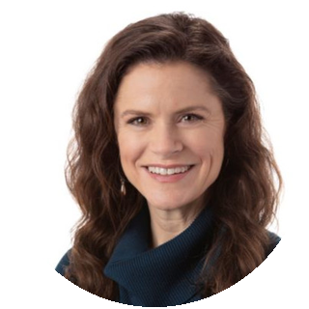  PHOTO SOURCE | Monique Brown  02 • FIRST  PROFILE / BIO | Knowledge Community Director  Aggie Square / Wexford | Startup ecosystem builder; previously led Growth Factory programming and advises regional founders. | Builds connections among university researchers, companies, investors and other partners at Aggie Square; listed as mixer host. | “Could you point me toward IntelliVasc or other resident medical-device startups and introduce me to someone responsible for engineering tests?”
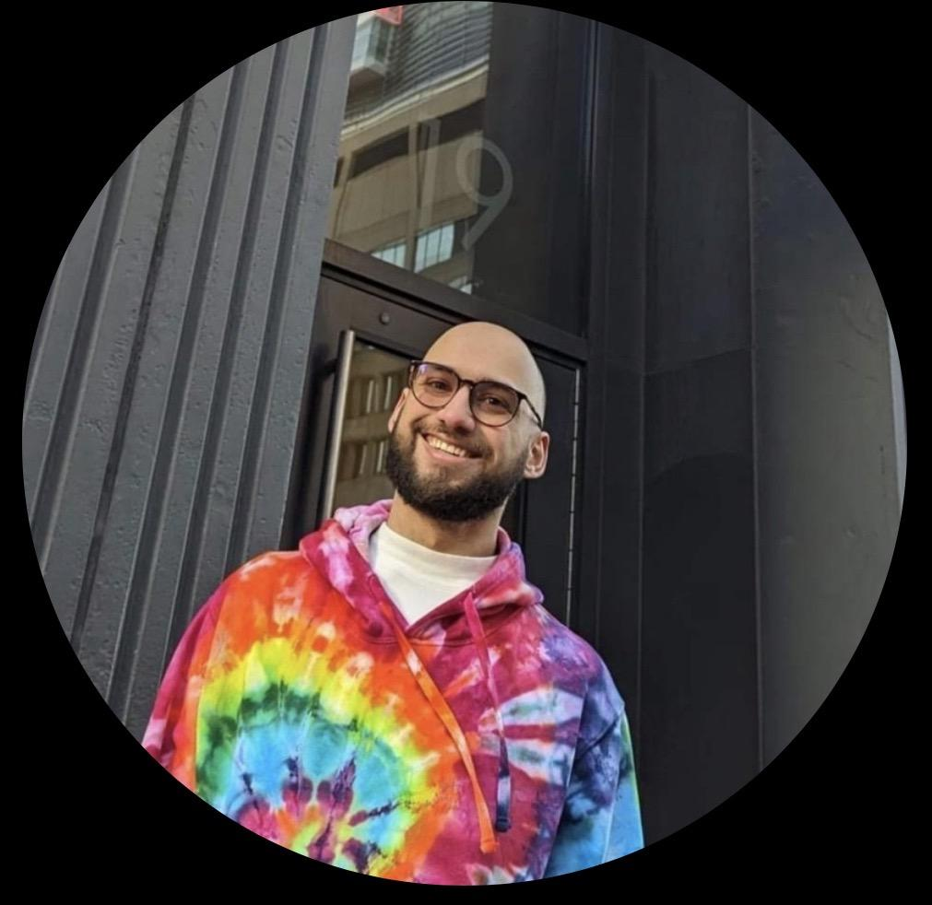  NO VERIFIED PHOTO | Armon Naddaf  03 • HIGH  PROFILE / BIO | Software Engineer  Persist AI | Engineering background including UC San Diego; public professional information links him to software engineering and biotech automation. | Contributes to a company automating pharmaceutical formulation workflows and combining software with laboratory machinery. | “How does your team validate instrument automation and test software interacting with lab hardware? Any companies needing a verification-focused intern?”
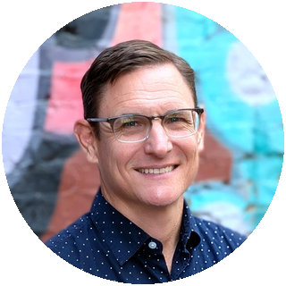  PHOTO SOURCE | Brian Heller de Leon  04 • HIGH  PROFILE / BIO | Managing Director, Prosperity Programs  Valley Vision | Former Kaiser Permanente community-health strategist; experience with workforce pathways, nonprofit management and regional economic development. | Leads programs coordinating workforce development and inclusive economic growth across greater Sacramento. | “Which biotech or medical-device employers are expanding, and who is offering paid engineering internships or work-based learning in Sacramento?”
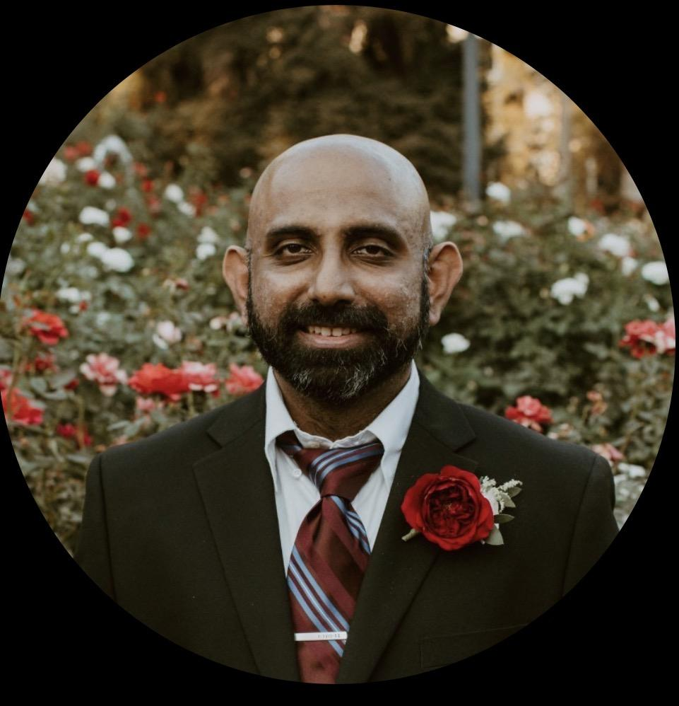  NO VERIFIED PHOTO | Nithin Dhananjayan  05 • EXPLORE  PROFILE / BIO | Engineer / entrepreneur (self-reported)  Stealth-mode venture | Public LinkedIn describes 20+ years spanning engineering, computer science and biophysics, including software testing. | Reports stealth-mode work; current product and employer affiliation not independently established. | “What does rigorous software or device verification look like at an early-stage biotech startup? Is there a small paid project I could prove myself on?”
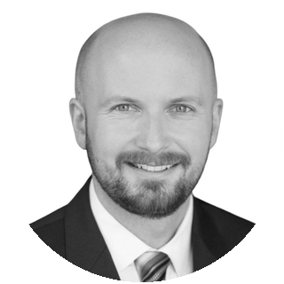  PHOTO SOURCE | Patrick Cormier  06 • NETWORK  PROFILE / BIO | CFO / fractional CFO  Infinant Health; Cormier Strategic Finance | CPA and UC Berkeley MBA, previously Deloitte; financing and operations for life-science startups. | Helps biotech firms raise capital, create financial plans and build systems as they grow. Current multiclient roles should be reconfirmed. | “Which local biotech or medical-device startups have recently funded product-development work and might take on a graduate engineering intern?”
NO VERIFIED PHOTO | Riccardo LoCascio  07 • NETWORK  PROFILE / BIO | Head of Partnering, Precision Proteins  Novonesis | UC Davis microbiology PhD and alum; extensive commercialization and business-development background in precision fermentation. | Develops strategic partnerships and evaluates scientific opportunities for industrial biotechnology products. | “Do you know Davis-area companies hiring engineering interns for instrumentation, automation, process validation or test development?”
  PHOTO SOURCE | Agamjot Sangotra  08 • SCIENCE  PROFILE / BIO | Postdoctoral Fellow  UC Davis Campana Lab | PhD in Molecular and Cellular Pathology (University of Michigan); studied treatments for Kennedy disease. | Investigates Schwann-cell signaling and peripheral nerve injury and regeneration, with emphasis on LRP1 biology. | “Are you seeing any collaborations involving nerve-interface devices, electrophysiology or translational neuroengineering? Who runs the device-side testing?”

A simple 20-second introduction
“I’m working on a UC Davis master’s in biomedical engineering and building experience with human neural acquisition systems. I want to work in industry verification engineering—automated tests, hardware/software reliability and evidence that a device meets requirements. Which local teams might need that?”
Follow-up: Ask for one specific person or company, record their exact name and the technical problem, then follow up with a short project idea. Do not ask every attendee for a job.

SOURCE LINKS Ajith Anand • Monique Brown • Armon Naddaf • Brian Heller de Leon • Nithin Dhananjayan • Patrick Cormier • Riccardo LoCascio • Agamjot Sangotra

